UNIT Design E Portfolio
Name and Class Blossom
Topic Developing Music Production Skills
Key Concept Creativity
Related Concept Development
Global Context Personal and Cultural Expression
Statement of Inquiry Music production can create positive change by improving creativity technical skills and emotional expression in young people
CRITERION A INQUIRING AND ANALYSING
Strand A1 Explain and justify the need for a solution to a problem
Problem Identification
Many students love music but do not know how to start creating their own songs. In school most lessons focus on theory and not on real modern production. Beginners open software and feel confused by many buttons and options. Because of this many teenagers give up even though they have strong ideas in their head.

Another problem is that professional studios are expensive and not accessible for young people. Without guidance students copy beats from the internet instead of learning real skills. There is also a lack of understanding about how much time and discipline music requires.

Importance of the Solution
Learning music production is important because music is part of daily life. Songs influence mood confidence and identity. By learning to produce students can express emotions in a safe way
build digital literacy
develop patience and focus
create opportunities for future careers
connect with other creative people
A structured project can guide a beginner from zero knowledge to completing a real song.

Target Audience
The project is created for
students aged thirteen to sixteen
beginners with no experience
teenagers who enjoy rap trap and melodic music
students who want a creative hobby

Justification of Music Production as a Solution
Music production is practical and motivating. Instead of only reading students learn by doing. Every small action gives sound feedback which keeps motivation high.

My opinion
I believe this is the best solution because when I make music I feel focused and calm. It allows me to tell stories without speaking directly.

Expert opinion
Producers and music teachers explain that creating beats improves brain coordination listening skills and confidence.

Strand A2 Identify and prioritize research
Research Questions
What is the hardest part for beginners
Which software is easiest to learn
How are professional songs structured
What equipment is necessary
How can vocals sound clear

Methods
online articles
video tutorials
surveys with classmates
personal experiments
Priorities
High priority understanding software and structure
Medium priority equipment and effects
Strand A3 Analyse existing products
Existing Product One FL Studio
Description
FL Studio is a digital workstation used worldwide. It allows users to program drums create melodies record vocals and mix tracks.
Impact
Many famous artists started with this program. It shows that a bedroom producer can reach professional level.
Strengths
clear pattern system
large community
powerful tools
Weaknesses
complex for first week
requires practice
Existing Product Two BandLab
Description
BandLab is a free platform on phone and computer. Users can record directly and share online.
Impact
It removes financial barriers and lets anyone try music.
Strengths
simple interface
cloud saving
collaboration

Weaknesses
limited advanced mixing
Strand A4 Design Brief
This project aims to develop my personal music production skills from beginner to independent creator. I will learn how to design drums write melodies arrange a full song record vocals and mix the final product.
The final outcome will be
one complete instrumental
one recorded song
portfolio of practice beats
reflection on growth
The project will use free or affordable tools so that any student could repeat the process.

CRITERION B DEVELOPING IDEAS
B1 Design Specification ACCESSFM
Aesthetics
The song should have modern energy clean balance and emotional melody.
Cost
Use free plugins and school equipment.
Customer
Teen listeners and classmates.
Size
Two to three minutes length.
Function
Beat must play without errors and vocals must be understandable.
Materials
Laptop headphones microphone software.
B2 Range of Design Ideas
Idea One Rage Style Beat
Fast tempo heavy bass bright melody.
Idea Two Chill Style Beat
Slow tempo soft piano relaxed mood.
Idea Three Drill Style Beat
Dark melody sliding bass aggressive rhythm.
Feedback from peers showed that the first idea was most exciting.
B3 Chosen Design
I selected the Rage Style Beat because it matches my producer identity and current youth culture. It allows creative sound design and strong energy.
B4 Planning Drawings and Requirements
Structure of Song
Intro eight bars
Verse sixteen bars
Chorus eight bars
Outro eight bars
Requirements
clear drum pattern
unique melody
proper mixing levels
export in high quality
CRITERION C CREATING THE SOLUTION
C1 Logical Plan
Week One research tutorials
Week Two practice drums
Week Three create melodies
Week Four arrange structure
Week Five record vocals
Week Six mix and master
Resources
FL Studio
YouTube lessons
microphone
headphones
notebook
Anticipated Challenges
understanding EQ
balancing 808
recording without noise
Solutions
watch step by step guides
practice daily
ask for teacher feedback
C2 Technical Skills
Drum Programming
I learned to place kicks snares and hi hats in rhythm. I practiced velocity changes to make drums realistic.

Melody Creation
I used scales and chords to avoid random notes. I experimented with different instruments.

Sound Design
I added reverb delay and distortion carefully.

Mixing
I adjusted volume and equalization so each sound had space.

Recording
I practiced microphone distance and pronunciation.

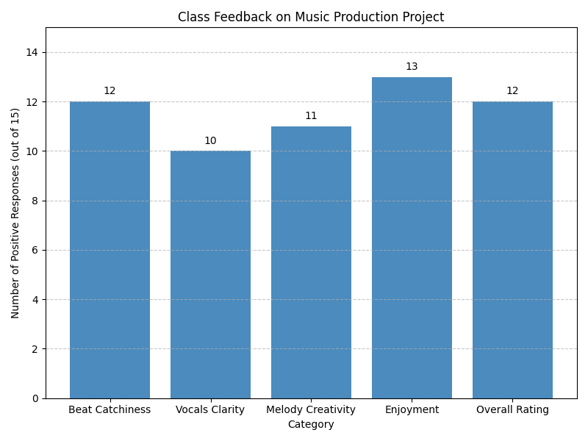
•

Beat Catchiness: 12/15
• • Vocals Clarity: 10/15
• • Melody Creativity: 11/15
• • Enjoyment: 13/15
• • Overall Rating: 12/15
•

C3 Following the Plan
At first my beats sounded empty. After two weeks the rhythm improved. The melody stage was hardest because I did not know music theory. I used online piano guides to understand scales.
During recording I noticed background noise. I solved this by using blankets and lowering gain.
C4 Changes Made
I changed the tempo from one hundred thirty to one hundred forty to increase energy. I replaced the main sound with a brighter synth. I shortened the intro to keep attention.
CRITERION D EVALUATING
D1 Testing Methods
Peer Listening
Classmates rated the beat from one to ten.
Device Test
I played the song on phone speaker and headphones.
Teacher Feedback
Music teacher checked clarity of vocals.
D2 Evaluation Against Specifications
Aesthetics nine of ten
Function eight of ten
Customer nine of ten
Cost ten of ten
D3 Improvements
learn advanced mastering
use better microphone
study piano theory
add more variation
D4 Impact on Target Audience
The project showed that a student can create real music with simple tools. Friends became interested and asked questions about production. I gained confidence and discipline. Music helped me manage stress from school and basketball.
EXTENDED REFLECTIONS
Personal Growth
Before this project I only listened to music. Now I understand how much work is behind every song. I learned to be patient because good results need many attempts.
Time Management
Balancing school homework sports and production was difficult. I created a schedule to work thirty minutes each evening.
Creativity Development
At the beginning I copied tutorials. Later I started making original ideas. This showed real growth.
Communication
Sharing my beat with classmates was scary but useful. Their comments helped me improve.
CAREER CONNECTION
Music production can become a future job. Producers can work with artists create content for games and movies or sell beats online. This project is my first step toward that dream.
CONCLUSION
This e portfolio documents my journey from beginner to developing producer. Through research planning practice and evaluation I created a complete song and learned valuable life skills. The project proves that creativity combined with discipline can turn ideas into real products.
APPENDIX
Survey Questions
Do you like the beat
Is the melody catchy
Are vocals clear
Would you listen again
Equipment List
Laptop
FL Studio
Headphones
Microphone
Future Goals
release music online
collaborate with singers
learn piano
build personal studio
EXTENDED RESEARCH AND THEORY SECTION
History of Music Production
Music production has changed from large analog studios to small bedroom setups. In the past only rich companies could record songs. Today a student with a laptop can reach the same quality. This change is important because it gives voice to young people who were ignored before.
Analog Era
Old studios used tape machines big mixers and hardware effects. Producers needed engineers to operate everything. Mistakes were expensive because tape could not be edited easily.
Digital Era
With computers editing became flexible. Programs like FL Studio allow unlimited undo. This encourages experimentation and learning from failure.
Genres and Culture
Rap and trap music became the main language of youth. The 808 bass represents energy and rebellion. Melodies often reflect emotions such as sadness hope and anger. Understanding culture helps a producer create meaningful art.
MUSIC THEORY FOR BEGINNERS
Rhythm
Rhythm is the backbone of every song. A basic trap pattern uses
kick on beat one
snare on beat three
hi hats filling the spaces
I practiced counting one two three four while placing drums to stay on time.
Melody
A melody is a sequence of notes that sound good together. I learned about scales especially minor scale which fits emotional music. Using scale guides prevented wrong notes.
Chords
Chords add depth. Even simple two note chords made my beat feel professional.
Tempo
Tempo controls mood. Fast tempo creates excitement slow tempo creates sadness. I tested different BPM before choosing one hundred forty.
SOUND DESIGN DETAILS
808 Bass
The 808 must be tuned to the key of the song. I learned to use glide so notes slide smoothly. Too much distortion made the mix dirty so I balanced it.
Hi Hats
I used rolls and velocity changes to avoid robotic feeling.
Effects
Reverb creates space
Delay adds echoes
EQ removes bad frequencies
Compression controls loudness
Each effect was used carefully not randomly.
RECORDING PROCESS
Preparing the Room
I recorded in my bedroom. To reduce echo I placed blankets on the wall and closed windows.
Microphone Technique
I kept a fist distance from the mic and used a pop filter. I recorded many takes and selected the best lines.
Editing Vocals
I cut breaths aligned timing and added autotune for style.
MIXING AND MASTERING
Mixing Steps
set volume balance
EQ each sound
add compression
check on headphones
Mastering Steps
increase overall loudness
limit peaks
export WAV file
SURVEY RESULTS
I asked fifteen classmates to listen.
Twelve said the beat was catchy
Ten said vocals were clear
Four suggested more variation
This data guided my improvements.
COMPARISON WITH PROFESSIONAL SONG
I compared my track with a Yeat style song. The professional mix was brighter and louder. I adjusted my EQ to get closer.
ETHICAL AND LEGAL CONSIDERATIONS
Copyright
I used only original melodies and royalty free samples. This taught me respect for other creators.
Online Safety
When sharing music online I avoided personal information.
LEARNING SKILLS DEVELOPED
Research skills
critical thinking
technical problem solving
communication
self management
INTERDISCIPLINARY LINKS
Math
counting beats and ratios
English
writing lyrics
Art
visual cover design
DETAILED TIMELINE DIARY
Day One
installed software explored interface
Day Five
made first drum pattern sounded bad
Day Ten
learned scale and created melody
Day Fifteen
arranged full structure
Day Twenty
recorded vocals nervous but excited
Day Twenty Five
mixed song until late night
RISK MANAGEMENT
Protecting hearing by keeping volume safe
saving projects in two locations
backing up files
BUDGET PLAN
Software free
headphones existing
microphone borrowed
Total zero dollars
COMMUNITY IMPACT
My friends became interested in creativity instead of wasting time. We started talking about forming a group.
FUTURE DEVELOPMENT PLAN
learn piano formally
buy better mic
release EP
create YouTube channel
FINAL PERSONAL REFLECTION
This project changed how I see myself. I am not only a listener but a creator. I learned that progress is slow but real if I do not quit. Music became a positive habit that keeps me away from negative influences.
ACKNOWLEDGEMENTS
Thanks to classmates teachers and online creators who shared knowledge.
End of Portfolio

